**ePre-selection criteria for the CBM lambda baryon ML project**

χ2geometrical, χ2primpos, χ2primneg, χ2topo > 0 ; χ2>=0

**mass > 1.077** mass should be equal or greater than the sum of mass of proton (0.938) and pion(0.139)

**0<l <80 (ldl > 0)** - Fixed target geometry dictates that lambda should decay after the target

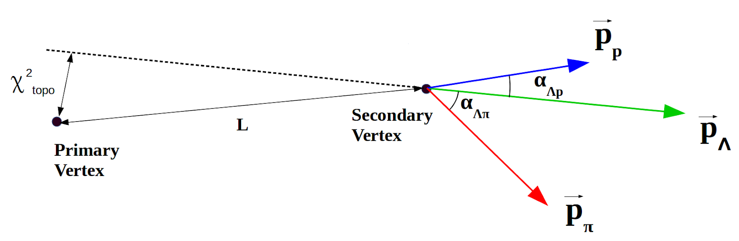

**distance > 0** distance between two distinct points (in our case , tracks) is always non negative

**distance <100** because the largest station of STS has an area of 100cm2

**cosinepos, cosineneg > 0** because cosine between particle and lambda momentum is in range 0, $π/2$, fixed target geometry dictates this

pT, rapidity and φ analysis

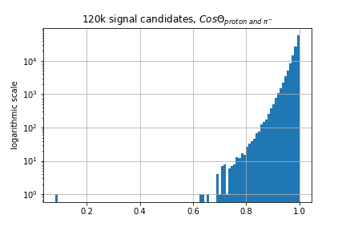

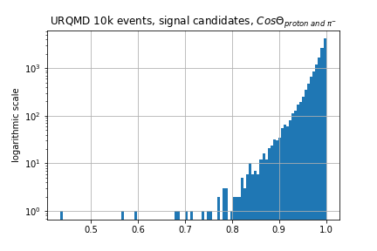

**|x|, |y| < 50,** largest station of STS has an area of 100cm2, if the aperture is in the center then each axis should have a 50 cm length (x & y=±50cm)

**z<80** size of detector (if lambda decays at z=80 then its daughters will leave two hits, one in station 7 (at 90 cm) and one at station 8 (at 100 cm away from the target). But we take at least three hits to reconstruct a track, so cannot reconstruct that lambda.

Distributions with the cuts could be found here

[link](https://drive.google.com/file/d/12WskOPjjTOfDnvoIDTFYp7u40ppDEgYd/view?usp=sharing)

**Need further suggestions**

* χ2geometrical, χ2primpos, χ2primneg, χ2topo < 25 x106 , STS has a resolution of 25 μm, so anything above this in terms of errors does not make sense
* $η=-ln(tan θ/2)$ and STS covers the polar angles between 2.5o and 25o. This might constrain η in 3.8 and 1.5 but this removes around 4.5 % signal candidates from a URQMD generated 10k events data set. So we select 1<η<4 and it removes less than 0.3 % signal candidates.

pT, rapidity and φ analysis

before eta cut signal

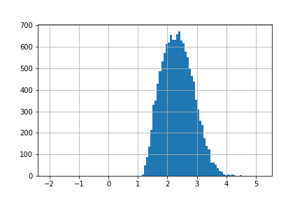

after eta cuts 3.8 and 1.5

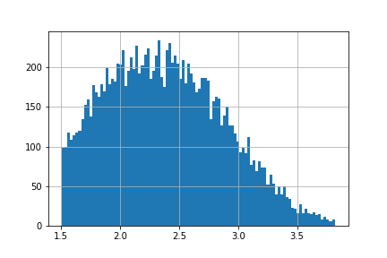

1<η<4

